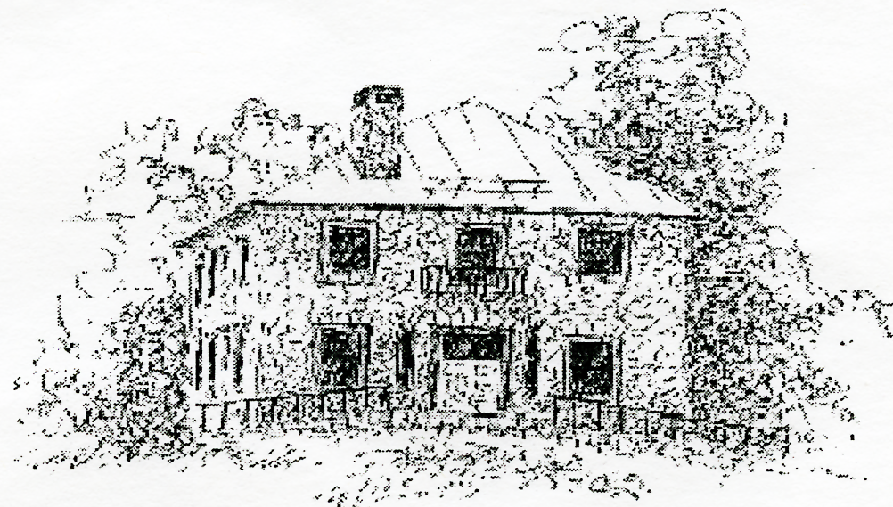 | The Friends of the Babcock Library is an independent, non-profit volunteer organization working to further the educational and informational needs of the community through its support of the Babcock Library

Friends of Babcock Library: Membership Drive

Spring 2026

Dear Friend of Babcock Library:

As always, we thank you for your continued dedication to our organization. We look forward to serving you for another year! We hope that you will renew your current membership.
Membership benefits include:

- Early access to the annual Used Book Sale;
- Advanced / priority registration to Library Programs.
Here are some of the projects we support:

- Awarding a $1,000 scholarship to a local graduating high school student;
- Book purchases;
- Children’s story time & crafts;
- Donation of new books to Ashford Elementary School;
- Little Free Lending Library Maintenance;
- Passes for free admission to museums;
- Support for special library events.

Please support us in fulfilling our mission by renewing your membership to the Friends of Babcock Library today.
Please contact Elaine with any questions. (ewilmespandolfo@gmail.com)

The Friends of Babcock Library Renewal Form

Name _________________________________________________________________________________
Mailing Address _________________________________________________________________________
Email ____________________________ Phone (best number to reach you) ________________________

Would you like to receive a copy of our monthly meeting minutes? __Yes ___No

Please renew my membership at the following level:

- Friend $10
- Good Friend $25
- Special Friend $50
- Best Friend $100
- Generous Friend $200

I am willing to help with Friends’ programs and events:

- Refreshments
- Fund-raising events
- Book sales
- As needed

Please make checks payable to Friends of Babcock Library and mail to:
Babcock Library  25 Pompey Hollow Rd  Ashford, CT 06278 | -or- | Drop off the form/payment at the library

